# **Abstract**

The goal of this scripted walkthrough and demo is to teach, provide context, and practical application for a customer or solutions professional (SSP, PSS, ATS, TSP, or CSA) to address Azure EA, Billing, and Azure Cost Management.

The following four sessions will drive you through the EA portal into using Azure Cost Management to visualize usage and consumption. In addition you will learn how to setup PowerBI connection into Azure EA Usage Details and leverage Azure Advisors.

# **Session 1: EA and Hierarchy**

* When possible have customer navigate and experience their environment, if you need to practice try using EA Demo Portal, Azure Portal, Your MSDN Subscription.



Start with EA Portal ea.azure.com – ensure your customer has access as a EA Admin.

Once logged in navigate the EA Portal

Explain Hierarchy Business Logic Top VS. Technical\Operation Logic Below:

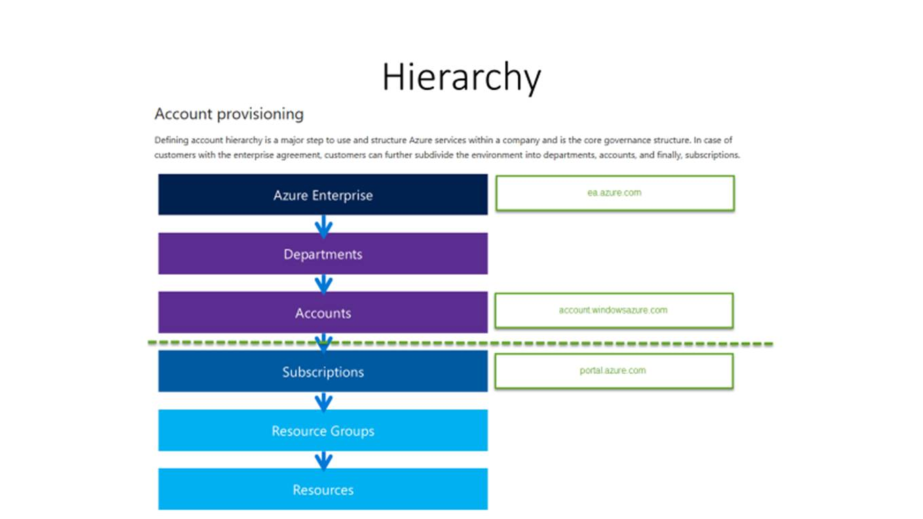

Show them how to create EA Admins and Account Owners, explain the difference and ensure they always use Auth Type “Work or School Account” followed by the persons corporate email address. Do not use Auth Type “Microsoft Account” – that is @live.com or @gmail.com the identity is not stored in their AAD Tenant and if the persons leaves the org, you manually clean this up – another touchpoint.

Mention in Depth EA Portal Training videos can be found here: <https://channel9.msdn.com/blogs/EA.Azure.com>

We will now show briefly where the data is stored and explore the Usages Details CSV report briefly to show the data structure.

1. Log in to the Enterprise portal (ea.azure.com), and navigate to Reports > Download Usage
2. Open CSV in excel and walkthrough the columns, to note Meter, SubMeter, Consumed Units, Quantity, ResourceName, Tags, are some of the columns to highlight.

*Make a note to the customer that the data in these Usage Details get populated a few times throughout the day, this is not up to the minute usage data but will be accurate to the last day plus some time today.

This is great but very unwieldy we need to interpret and visualize this data to take actions. We now will talk about grabbing the UsageDetails Data Table seen in the .csv into PowerBI and Azure Cost Management(Formerly Cloudyn) to do this we need to get a API Key.

**(Optional) – Show Power BI,** does customer have Power BI licensing, can also show sample Power BI App, but will need licensing to access Usage Details Data Tables or drop CSV from last section into a storage account and connect that way.

> API Access Key to generate or retrieve the API key.

<https://docs.microsoft.com/en-us/azure/billing/billing-enterprise-api#enabling-data-access-to-the-api>

There is also a good channel 9 video around the reporting and API key I usually send this to customers as well at times:

*“This is one of my favorite ones as it goes into accessing your EA billing through Power BI, really neat stuff.*

[*Overview of Downloading Usage*](https://channel9.msdn.com/blogs/EA.Azure.com/EA-Reporting-and-Power-BI-Usage-for-Enterprise-Admins)*:*

*@0:00 EA Billing Usage*

*@4:00 filtering, view by hierarchy*

*@6:15 Download usage –* [*Additional Video*](https://channel9.msdn.com/blogs/EA.Azure.com/EA-Reporting-Detailed-Usage-in-the-Download-Usage-Files) *using pivot tables in excel*

***@8:30 API access key for developers, also used for Power BI reporting***

*@9:20 Price Sheet, explanation of unit of measure used and is different from usage billing*

***@10:40 Power BI***

*@11:30 Demo*

*@13:15 Dashboard view in Power BI*

*@14:40 Default dashboard*

*For additional details and videos you can check out:*

[*All EA videos*](https://channel9.msdn.com/blogs/ea.azure.com)*”*

Now we have the Enrollment Number top left number in ea.azure.com portal and API Key (Copy API Key and post in notepad, ensure you have the entire key, sometimes people copy part of the visible key, there is a expand dropdown button before you copy it in portal.)

***Go to powerbi and sign in***. at the home screen got to GET DATA yellow button bottom left, and get data from online services. In wizard search for Azure and choose the Microsoft Azure Consumption Insights PowerBI pack, another wizard will start and enter the enrollmentid, # of months I do 12 typically, and Next and enter API Key.

Once done PBI will have the content pack show the dashboard but also show the reports section, bottom tabs of reports section show several predefined reports.

***If possible go to the DataSets area*** and far right hand drill down in explorer and show the UsageDetails Table again, you can then generate your own drill down/up reports using fields from the UsageDetails Table, show the filtering fields and ordering capabilities. I typically use a PIE graph and choose subscriptions names, date, cost, product, sub-meter category and arrange and organize show the filter for Date\Time last 30 days or month and then show right click on the pie graph drill down and drill up.

# **Session 2: Azure Cost Management**

1. In portal.azure.com goto Cost Management + Billing

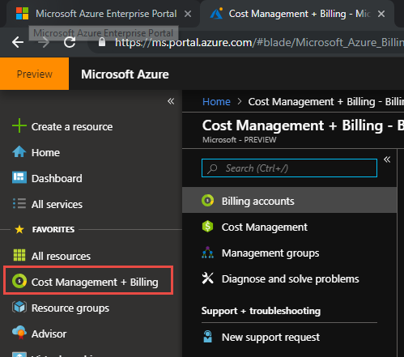

1. Go to Open Cost Analysis

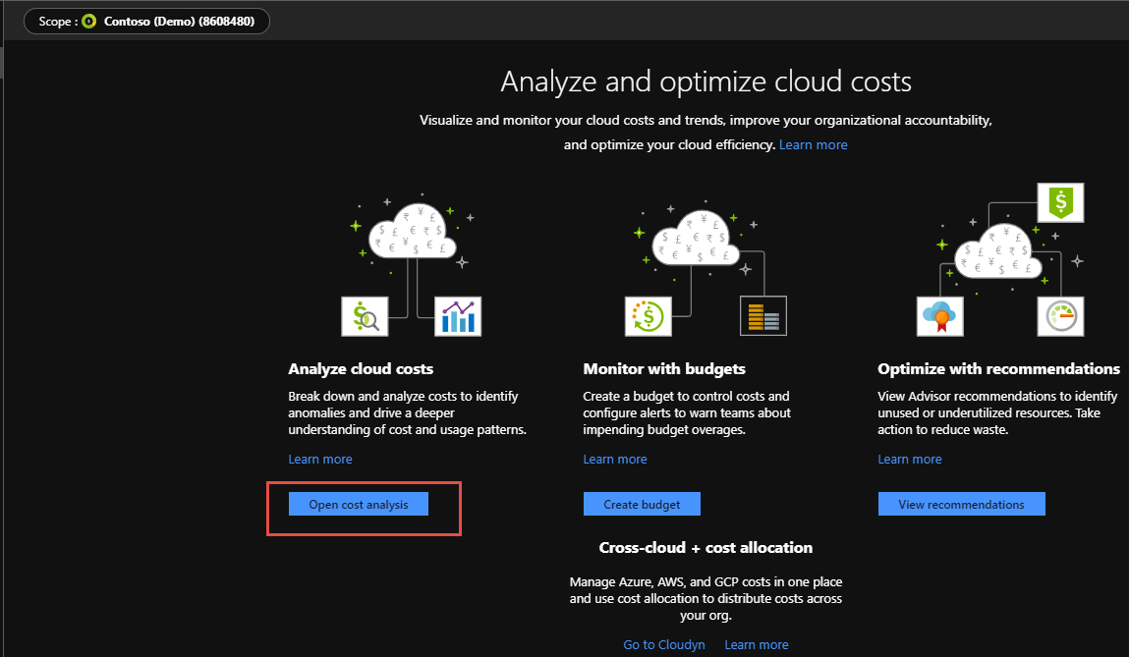

1. Change Scope – Be sure to mention you can use scope to change EA overall spend or drill into individual subscriptions spending using the Cost Analysis tool

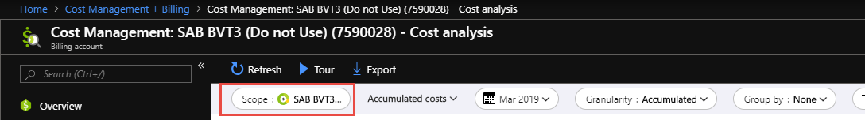

1. Be sure Scope is set to Contoso Demo



***Next lets highlight and talk about the quick hits view circles at bottom***. Great way to quickly see a pie representation of spend across different properties. Show and change the Location dropdown

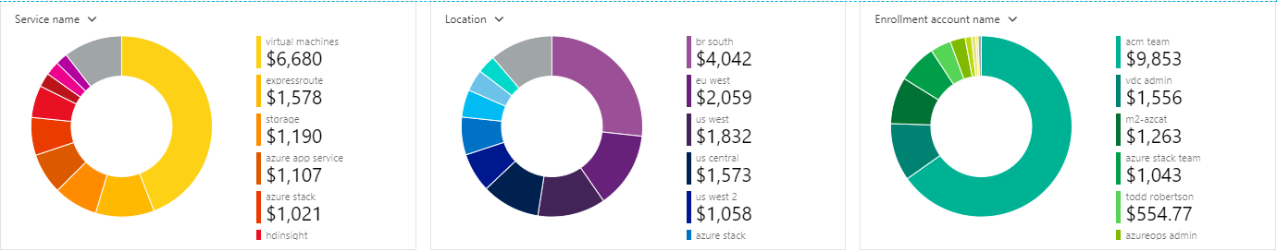

***To Meter Category – Explain the concept of High level metering in Azure costs***, For compute and VMs it is like a light switch we turn it on or off when using or like driving through a weigh station for storage costs how much data is in there.

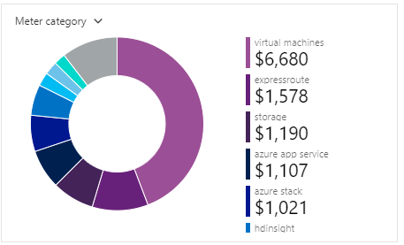

Maybe we want to examine the meters in more **specificity** Choose the drop down again and choose sub meter category, talk about the difference

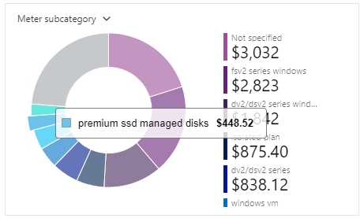

***Finally highlight that some services in Azure could have multiple different meters*** to their service: Choose the drop down again and choose meter

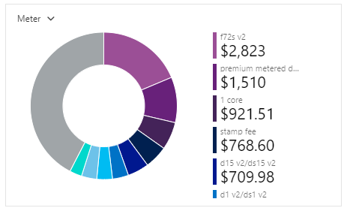

***This may be a good time to illustrate*** the multiple meters by going to Azure Pricing on the Price by Product Tab

<https://azure.microsoft.com/en-us/pricing/>

***Choose a service you are comfortable with explaining here***, note that the service has different tiers for costs and that there is an awesome FAQ for every service at bottom that cover many common questions and builds out scenarios

EX: <https://azure.microsoft.com/en-us/pricing/details/application-gateway/>

***Let’s return back to Azure Cost Analysis and focus on the top portion.*** To do this let’s choose a subscription and from the subscription go into Costs Analysis, we now see our scope is at a subscription level.

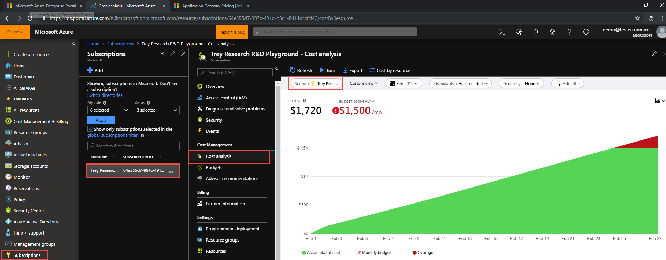

***Starting at the top lets talk about our date ranges for views***, we can do last month, this quarter, the current year and even custom date ranges in a calendar picker as needed.,

I typically change to show the last month

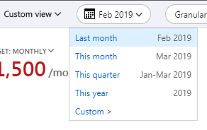

***Next I talk about the Granularity***, and change each one showing we can get accumulated costs, break down charges by month or day. Experiment and show how the area graph changes

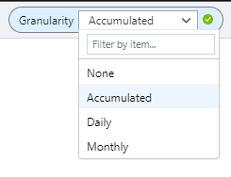

***Last we want to show we can group and filter***, show grouping by Meter, sub meter, resource groups, resource

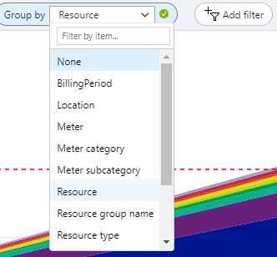

Finally showing we can change visualizations cycle through them.

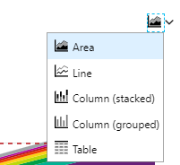

Okay that’s cool but let’s show some interesting visualizations you may be interested in:

Scope: Contoso

Date: last Month

Granularity: Daily

Group By: Resource

Graph: Area

We now have a view to see the peaks and valleys of cost by Resource name, did a resource expand or resize or increase or decrease in cost day over day, might be interesting to investigate further what happened on that peak or valley by going to the resource in Azure Monitor and looking at different metrics.

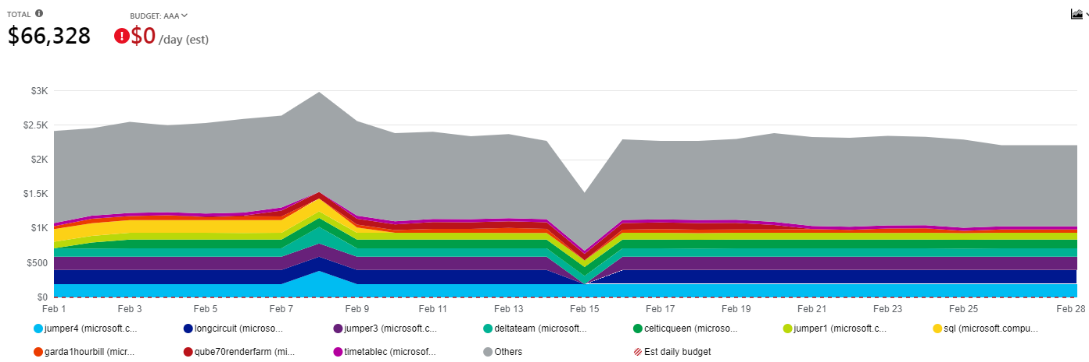

Scope: Contoso

Date: last Month

Granularity: Monthly

Group By: Subscription

Graph: Table

With this view we create a simple charge back monthly model we can send to the subscription owners, If we have Tags we can group multiple subscriptions or services across a single subscription to charge back to a cost center, department, business unit.

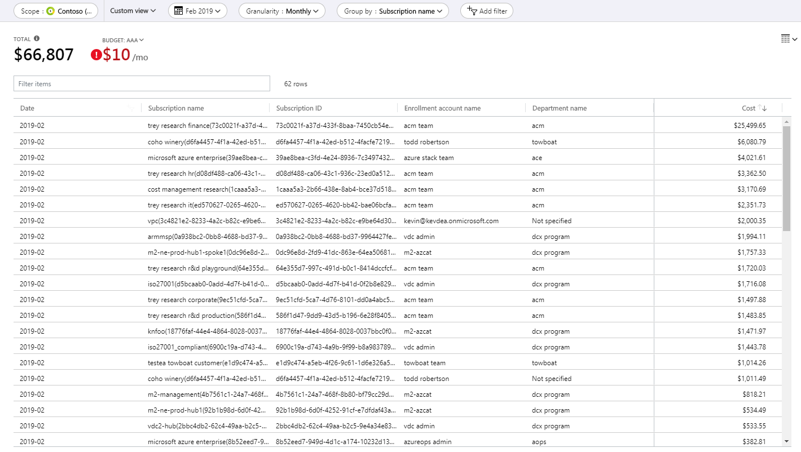

This might be a good time to talk about Tagging Resources in Azure. The three Tags we recommend at a minimum are

costcode: 0045c (costcenter) or titandevteam (department) or human resources (business unit)

owner: naswif@microsoft.com

environment: production

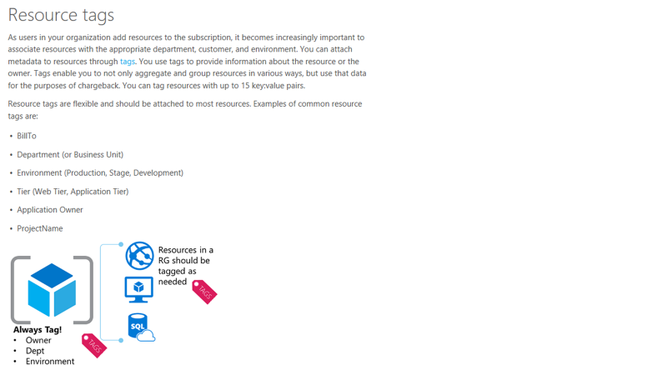

Forecasting Costs

Azure Cost Management also has a pre baked tile for Spending Rate and Forecasting the costs in the current month. To view this, go to the subscription and in the overview blade there is a Spending Rate and Forecasting tile.

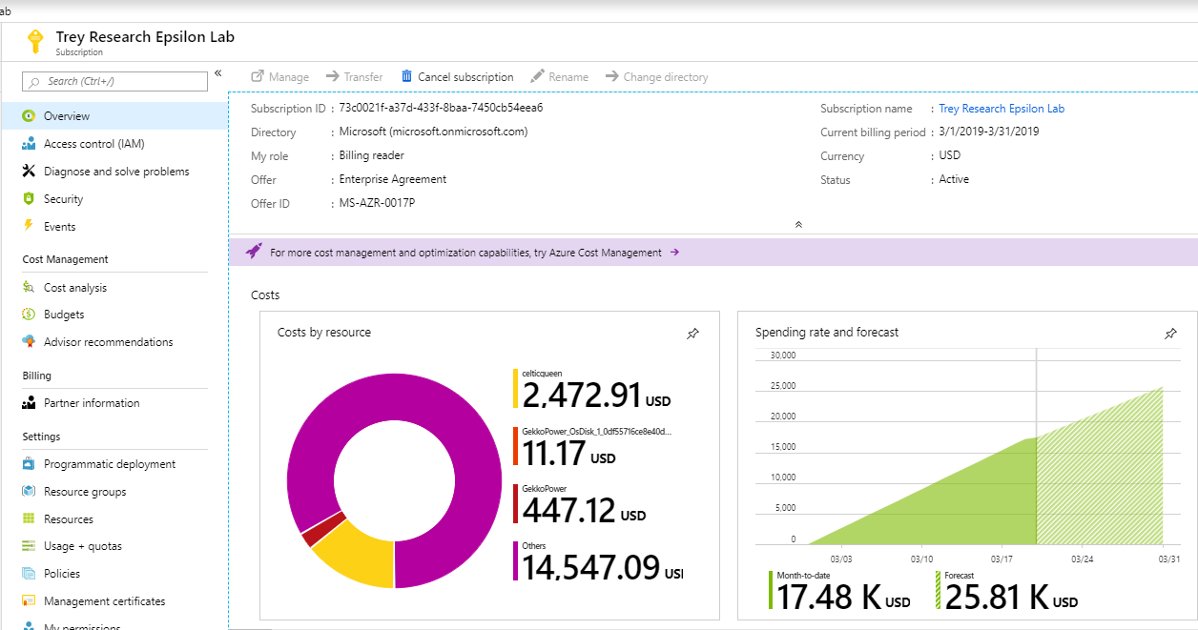

Finally on their subscriptions show the ability to create and manage budgets at the subscription level in portal.azure.com - <https://docs.microsoft.com/en-us/azure/cost-management/tutorial-acm-create-budgets> This is a huge ability that was hard to get to and do years ago in account.windowsazure.com, now very easy to do.

This is an early detection system alerting you too the fact someone or something is blowing out the budget set. In fact beyond setting budget emails alerts to the finance team you can run messages to Slack or Teams that are developing on the subscription and also automate shutting down resources or resizing them smaller and locking them from being changed until the end of the month.

Examples:

<https://docs.microsoft.com/en-us/azure/billing/billing-cost-management-budget-scenario>

<https://samcogan.com/enforce-bugets-with-azure-automation/>

The budget set now can go against the spend as a line,

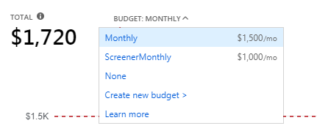

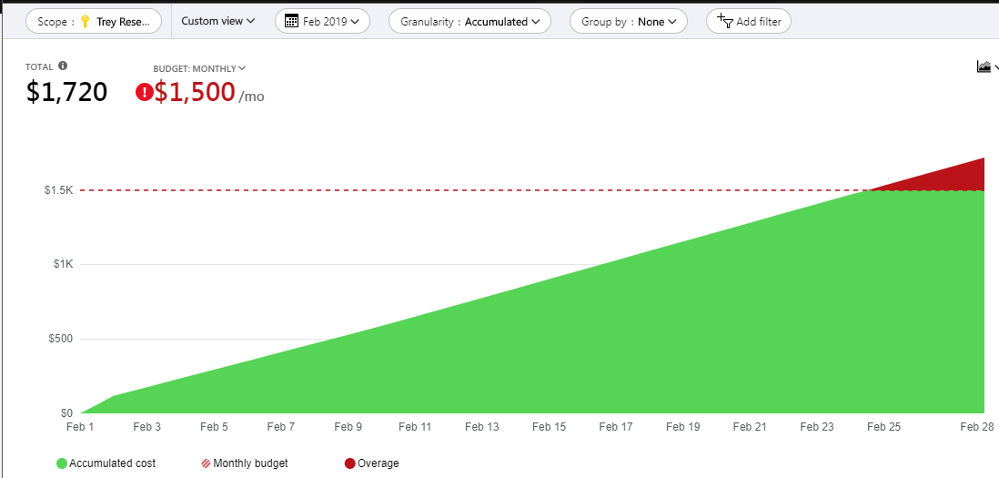

Budgets should never be static, part of the monthly operational review process budget may need to be adjusted up or down based on the project being deployed or expansion or retraction of the application solution.

***You have a good visualization you like pin it to a Dashboard***, you can create a Financial Operations dashboard and share it among people interested in the spending and consumption of Azure, make sure we are chasing smart money not dumb money.

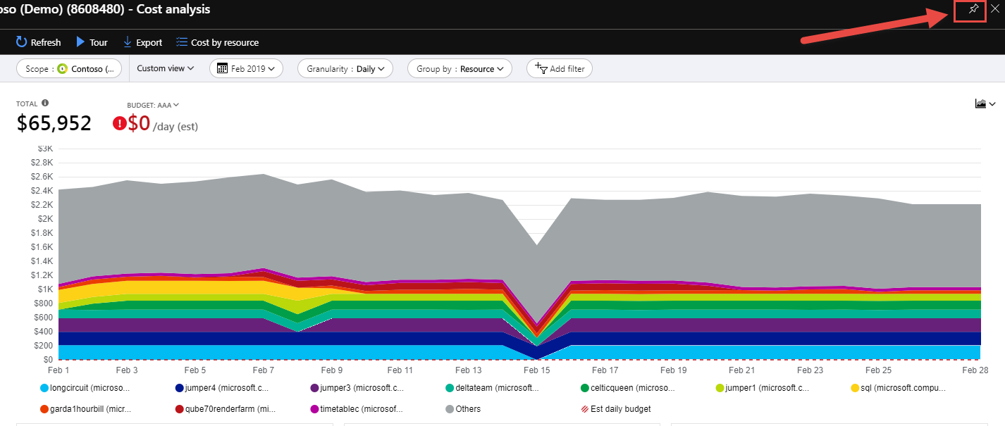

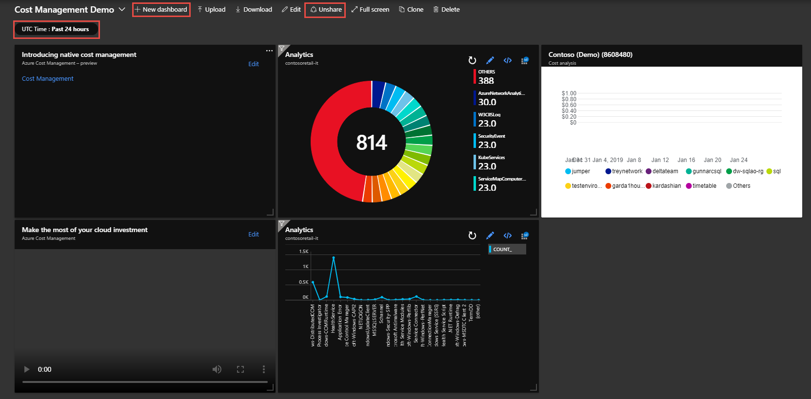

Finally one last place to check out if the cost by resource button at the top bar



We can view in an easy sortable and searchable view cost by each resource:

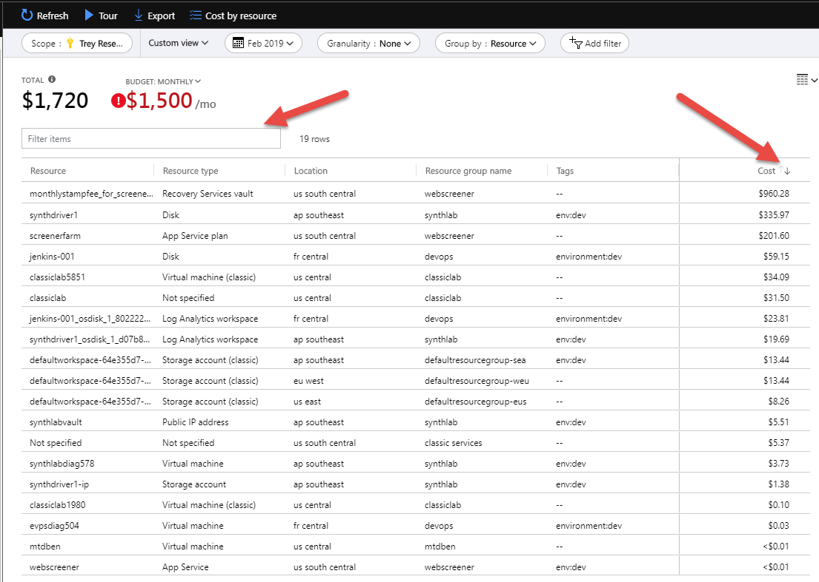

One last thing you can do now is ***export the data:***

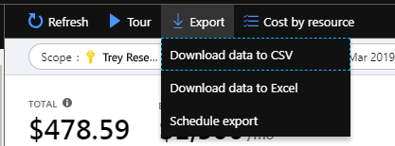

***Scheduling an Export allows you to send the billing usage details CSV*** into certain time grouped formats in a certain frequency, you can customize as well. NOTE as of testing if you built the monthly table view of summary charges it doesn’t export that table view you created. Exports seem to be a bit generic with the data.

***The export will land in a Storage Account*** of your choosing, think of the ways you can trigger off a new .csv blob landing in a storage account using Logic Apps. Ping someone on Slack or Teams, send an email report. Dump the csv data in ADLS or load the entries into DW. Maybe run a function parsing the data and executing other functions or runbook scripts.

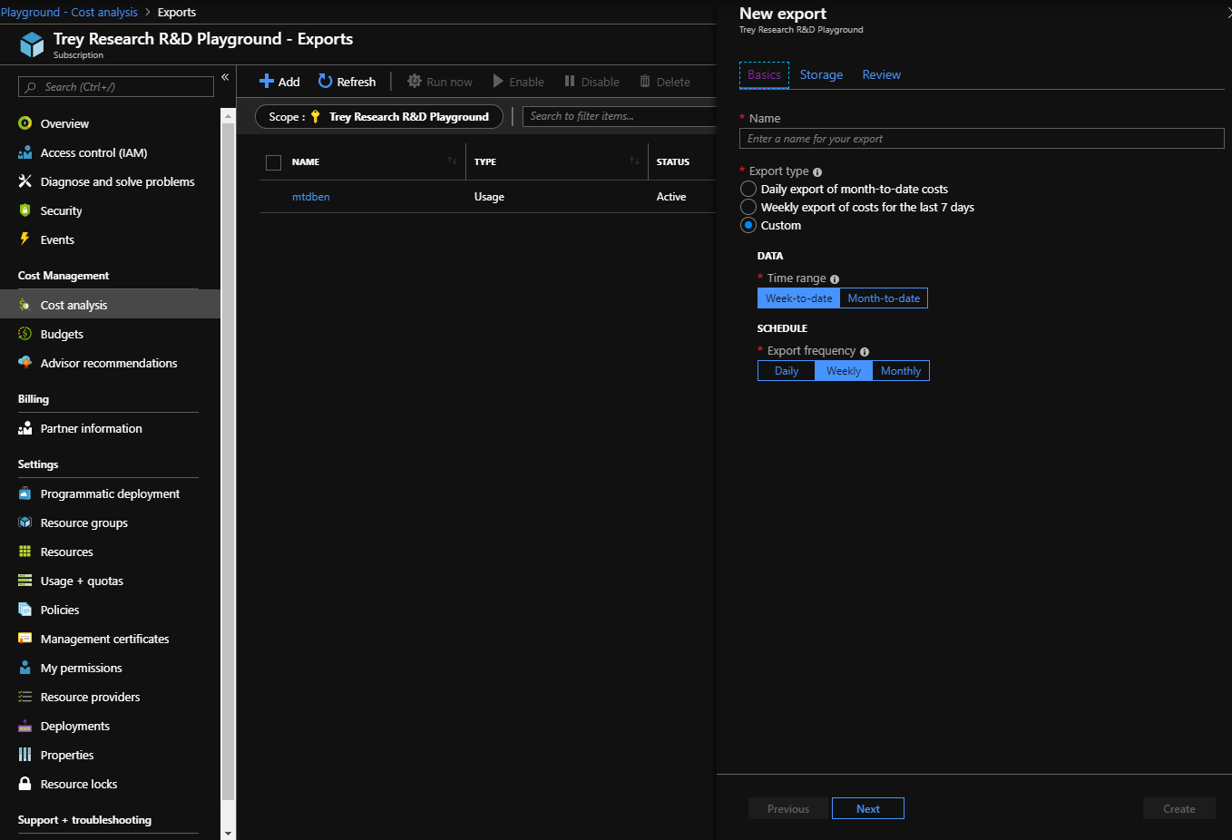

# **Session 3: Azure Advisors (Not Just for VMs) and Azure Monitoring**

Next we want to show Azure Advisors by clicking on the blade in the portal or searching in the top for Advisors

*If 1st time you may need to allow some time for Advisors to collect some data from the subscriptions

Performance and Cost are the two advisors we want to focus on.

[List of Performance Advisors (VM, SQL, SQL DW, WebApp, Storage and Disks)](https://docs.microsoft.com/en-us/azure/advisor/advisor-performance-recommendations)

[List of Cost Recommendations (VMs, PIPs, Express Route Circuits and VPN Gateway)](https://docs.microsoft.com/en-us/azure/advisor/advisor-cost-recommendations)

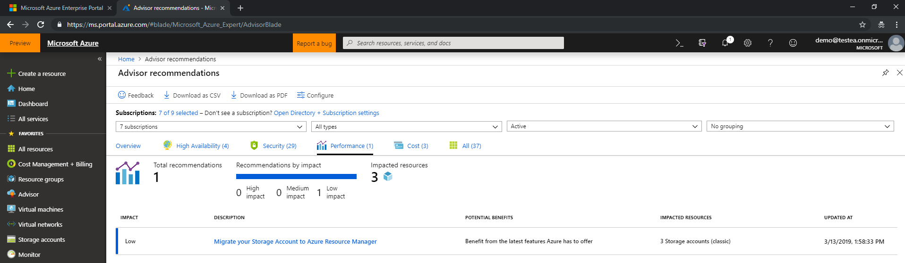

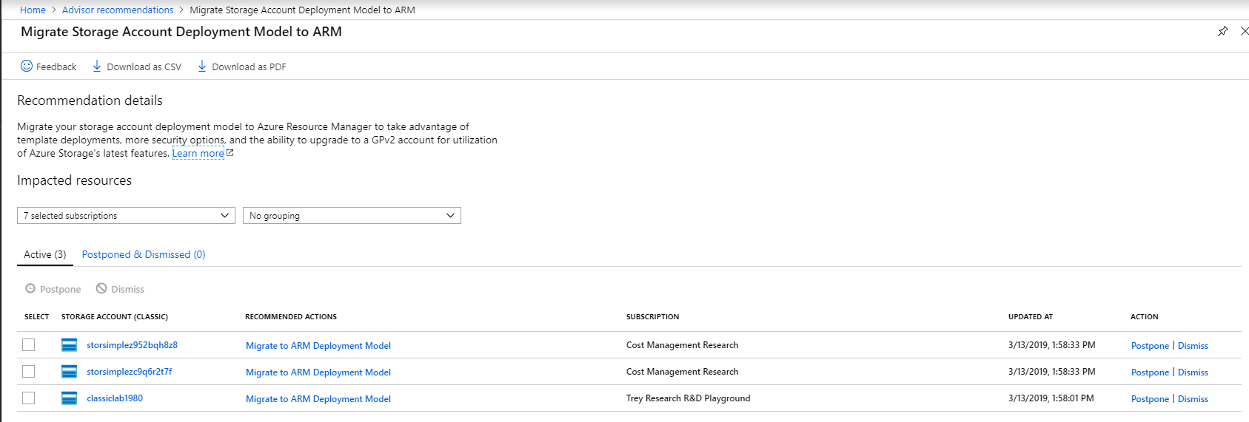

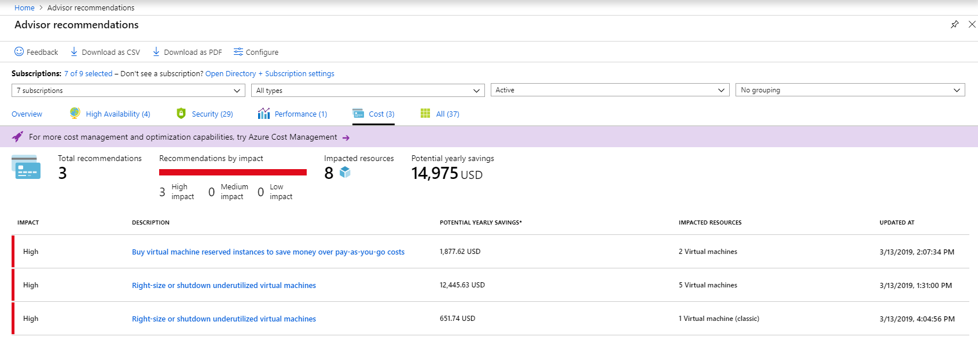

***Note that there is a configuration button in Advisors in the top***, by default advisors only flags VM under utilized by 5% or less, you can modify this to be more aggressive in resizing savings by going to 20% or less under utilized CPU.

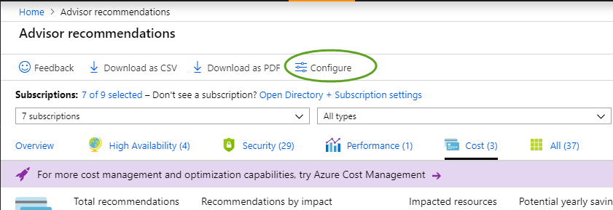

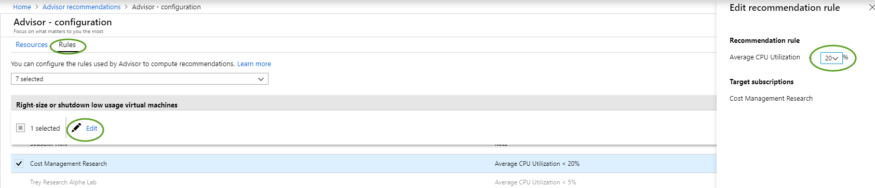



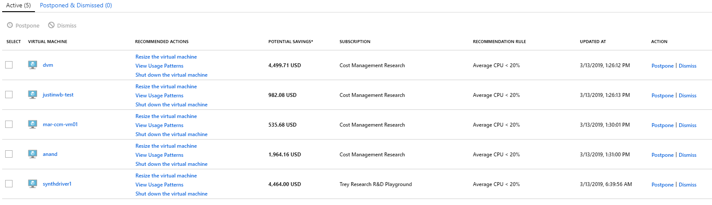

In Session 2 earlier we also talked about Cost by Resource, in many cases Advisors may not cover the most costly resource scenario. For instance we can look at a SQL DW DTUs to ensure it is right sized. To do this we can use Azure Monitor – Metrics to Look at consumed DTUs across a 30 day period to see if we need to resize or [even automate a pause in SQL DW](https://stephanefrechette.com/pause-azure-sql-data-warehouses-with-azure-automation/#.XIlvOihKiUk) to reduce costs further.

# **Session 4: Cloudyn Portal (Optional)**

*Azure Cost Management is taking the place of Cloudyn and new features will be added to ACM not Cloudyn. **Optional** – (Cloudyn) See attached guide – I typically ***do not show*** Cloudyn unless they already looked at it, or need to do a cost allocation model or something that is not baked into ACM.

In portal.azure.com go to subscriptions and choose a subscription click purple banner “[For more cost management and optimization capabilities, try Azure Cost Management](https://portal.azure.com/)”

Setup the Cloud Account for Azure EA: <https://docs.microsoft.com/en-us/azure/cost-management/activate-subs-accounts>

Ensure the account shows subscriptions activated with a green check mark under the column Azure Resource Manager (ARM)

End Session 1 – it will take 24-48 hours to download all the data into the Azure Cost Management (Formerly Cloudyn) portal.



# **References:**

You can generate a API key or use one to show off PowerBI Desktop \ or PowerBI Web

<https://docs.microsoft.com/en-us/power-bi/service-connect-to-azure-consumption-insights>

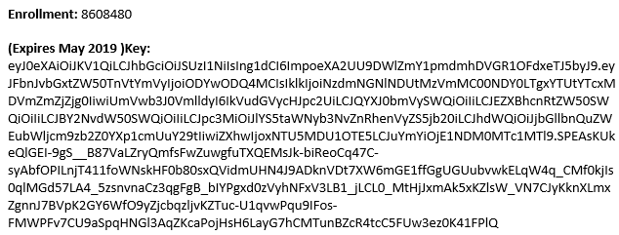

[Azure Advisors:](https://docs.microsoft.com/en-us/azure/advisor/advisor-overview) Compute and RIs

[Azure Storage Analytics Solution](https://github.com/Azure/azure-quickstart-templates/tree/master/oms-azure-storage-analytics-solution)